TELECOM MANAGEMENT SYSTEM

*PROJECT BY:*

***SIDDHARTH SINHA***

***PRAKASH TRIPATHI***

***DEVENDRA PATIL***

***AAKASH VISHWAKARMA***

***VIRENDRA RATHORD***

***SANTOSH SAVALIYA***



**DEPARTMENT OF INFORMATION TECHNOLOGY ATHARVA COLLEGE OF ENGINEERING**

**YEAR: 2017-18**

TABLE OF CONTENTS

|  |  |
| --- | --- |
| Serial No. | Topic |
| 1. | Introduction |
| 2. | Objective of the Project |
| 3. | Requirements |
| 4. | Working |
| 5. | Conclusion |
|  |  |
|  |  |

Introduction

Telecom system automates the management of Telecom services, which involves customer applications, entries, and enquiries. Queries (complaints) & Complaints

The customers are involved in the process of the customer registration and the entries based on the admin defining rules.

Telecom System also maintains the database of the customer’s entries applications and enquires.

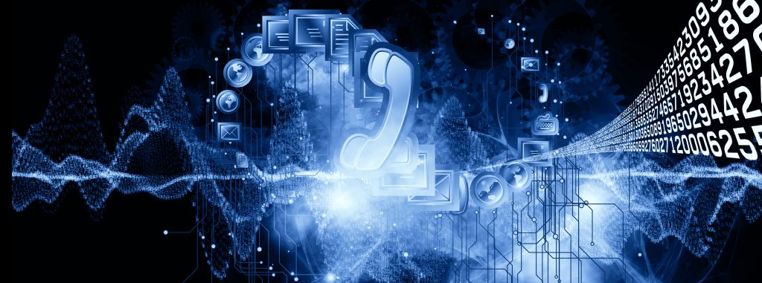

**OBJECTIVE OF THE PROJECT:**

   The main theme of this project is automation of the Telecom System and process the all activities through  on line. Here the main advantage of this system is to access this database globally for users.

         The customers see their connection status at any branch and also know their details at any branch. Here dynamically  generated the reports like previous details of the customer,

         The main advantages of this system are to reduce the time and also manpower. These two factors are very important to improve any organization. This system mainly concentration on these factors.

**The main Factors of this system are:**

* customer
* applications
* Entries
* Enquiries
* Complaints

Requirements:

**1. NetBeans :**

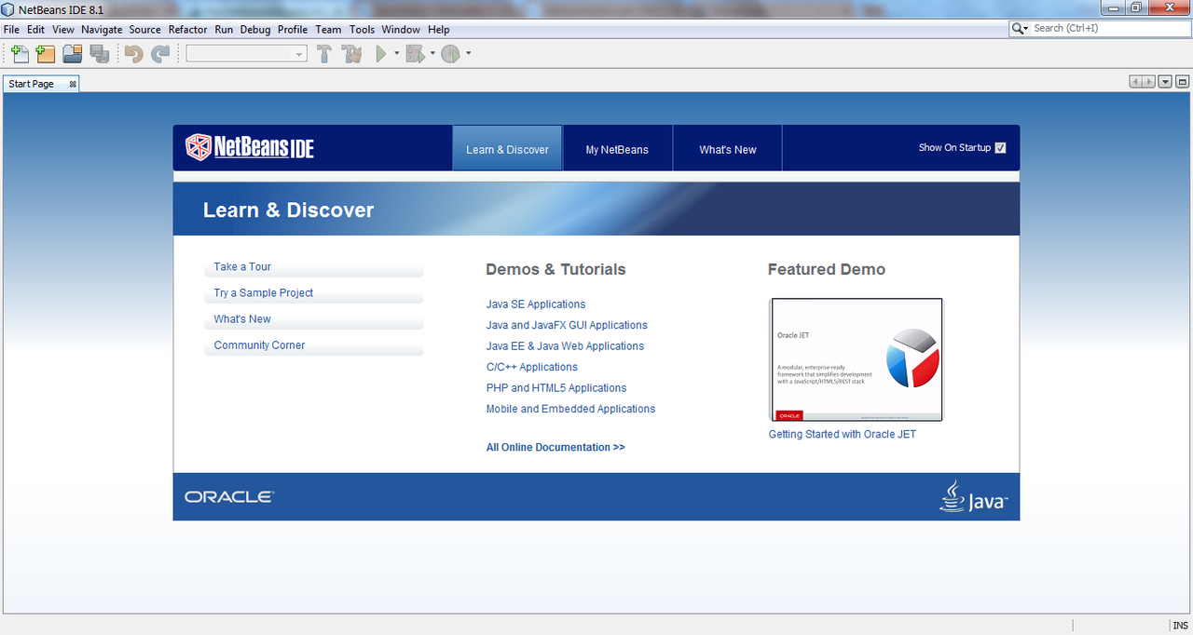

**NetBeans** is a software development [platform](https://en.wikipedia.org/wiki/Platform_(computing)) written in [Java](https://en.wikipedia.org/wiki/Java_(programming_language)). The NetBeans Platform allows applications to be developed from a set of modular [software components](https://en.wikipedia.org/wiki/Software_component) called *modules*. Applications based on the NetBeans Platform, including the NetBeans [integrated development environment](https://en.wikipedia.org/wiki/Integrated_development_environment) (IDE), can be extended by [third party developers](https://en.wikipedia.org/wiki/Third_party_developer).

The NetBeans IDE is primarily intended for development in Java, but also supports other languages, in particular [PHP](https://en.wikipedia.org/wiki/PHP), [C](https://en.wikipedia.org/wiki/C_(programming_language))/[C++](https://en.wikipedia.org/wiki/C%2B%2B)and [HTML5](https://en.wikipedia.org/wiki/HTML5).

NetBeans is [cross-platform](https://en.wikipedia.org/wiki/Cross-platform) and runs on [Microsoft Windows](https://en.wikipedia.org/wiki/Microsoft_Windows), [Mac OS X](https://en.wikipedia.org/wiki/Mac_OS_X), [Linux](https://en.wikipedia.org/wiki/Linux), [Solaris](https://en.wikipedia.org/wiki/Solaris_(operating_system)) and other platforms supporting a compatible [JVM](https://en.wikipedia.org/wiki/Java_Virtual_Machine).

The editor supports many languages from Java, C/C++, XML and HTML, to PHP, Groovy, Javadoc, JavaScript and JSP. Because the editor is extensible, you can plug in support for many other languages.

The NetBeans Team actively supports the product and seeks feature suggestions from the wider community. Every release is preceded by a time for Community testing and feedback. Over 18 million downloads of the NetBeans IDE to date, and over 800,000 participating developers, the NetBeans project is thriving and continues to grow.

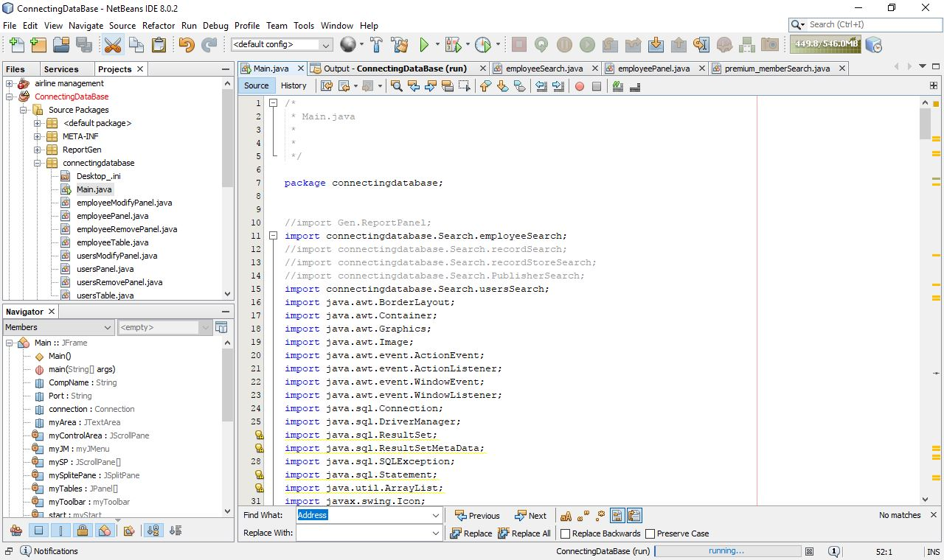

The NetBeans Platform is a [framework](https://en.wikipedia.org/wiki/Software_framework) for simplifying the development of [Java Swing](https://en.wikipedia.org/wiki/Java_Swing) desktop applications. The NetBeans IDE bundle for Java SE contains what is needed to start developing NetBeans plugins and NetBeans Platform based applications; no additional SDK is required.

Applications can install modules dynamically. Any application can include the Update Center module to allow users of the application to download [digitally signed](https://en.wikipedia.org/wiki/Digital_signature) upgrades and new features directly into the running application. Reinstalling an upgrade or a new release does not force users to download the entire application again.

The platform offers reusable services common to desktop applications, allowing developers to focus on the logic specific to their application. Among the features of the platform are:

* User interface management (e.g. menus and toolbars)
* User settings management
* Storage management (saving and loading any kind of data)
* Window management
* Wizard framework (supports step-by-step dialogs)
* NetBeans Visual Library
* Integrated development tools

**2. ORACLE 10G SQL DATABASE:**

[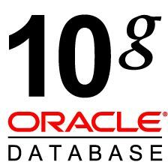](https://www.google.co.in/url?sa=i&rct=j&q=&esrc=s&source=images&cd=&cad=rja&uact=8&ved=0ahUKEwj5-bvDvqbXAhUEMo8KHehkDikQjRwIBw&url=http://allpcworld.com/download-oracle-10g-offline-setup/&psig=AOvVaw3dP5gFf-vTD66hL4HrJpnr&ust=1509938765631597)

Oracle Database 10g was the first database designed for grid computing, the most flexible and cost-effective way to manage enterprise information. It cut costs of management while providing the highest possible quality of service.

Oracle Database 10g transforms data centers from collections of separate, monolithic systems configured to handle individual applications to a smaller number of consolidated, shared pools of server and storage resources called infrastructure grids. Oracle’s unique scale-out architecture enables applications of all types to dynamically provision additional servers and storage resources as needed to meet their changing processing demands. It delivers dramatic cost savings and equally dramatic advancements in quality of service.

[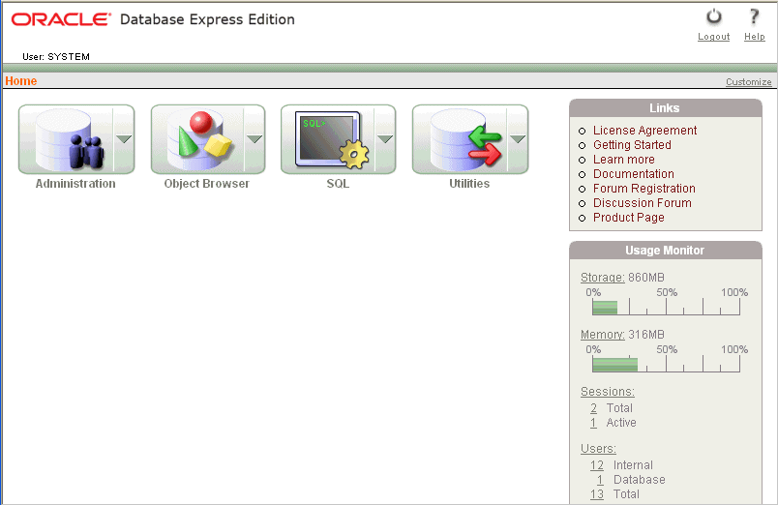](https://www.google.co.in/url?sa=i&rct=j&q=&esrc=s&source=images&cd=&cad=rja&uact=8&ved=0ahUKEwiI4vmHv6bXAhWKso8KHRinDHUQjRwIBw&url=https://docs.oracle.com/cd/B25329_01/doc/admin.102/b25610/toc.htm&psig=AOvVaw3dP5gFf-vTD66hL4HrJpnr&ust=1509938765631597)

|  |  |  |  |  |
| --- | --- | --- | --- | --- |
| **Column Name** | **Data Type** | **Nullable** | **Default** | **Primary Key** |
| NAME | CHAR(100) | No | - | - |
| ADDRESS | VARCHAR2(4000) | No | - | - |
| PHONE | NUMBER | No | - | - |
| AGE | NUMBER | No | - | - |
| GENDER | CHAR(10) | No | - | - |
| ISMEMBER | NUMBER | Yes | - | - |
| ID | NUMBER | No | - | - |
| MEMBERSHIP_END_DATE | NUMBER | Yes | - | - |
| MEMBERSHIP_SERIAL | NUMBER | Yes | - | - |
| |  |  |  | | --- | --- | --- | |  |  | 1 - 9 | | | | | |
| **Column Name** | **Data Type** | **Nullable** | **Default** | **Primary Key** |
| NAME | CHAR(100) | No | - | - |
| ADDRESS | VARCHAR2(4000) | Yes | - | - |
| Phone.no | NUMBER | No | - | - |
| NATIONALITY | CHAR(100) | Yes | - | - |
| |  |  |  | | --- | --- | --- | |  |  | 1 - 4 | | | | | |

WORKING

1. As soon as the window opens the default page is user table in the database.

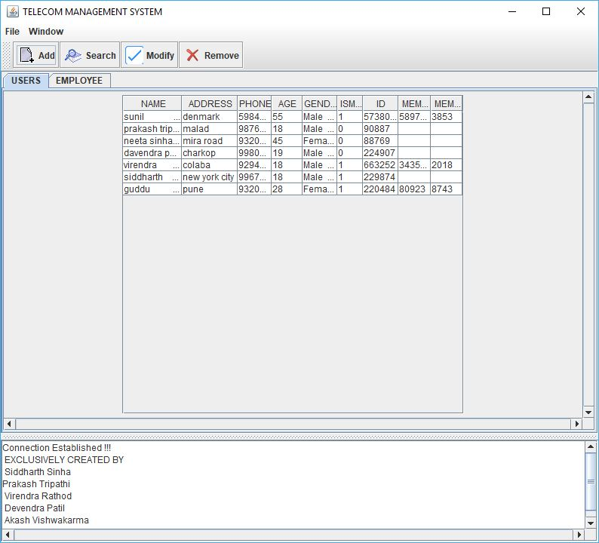

1. Click on ‘Add user’ to add users & fill the required data (name, address, phone, age, gender, id) and if already a member (membership date & serial).

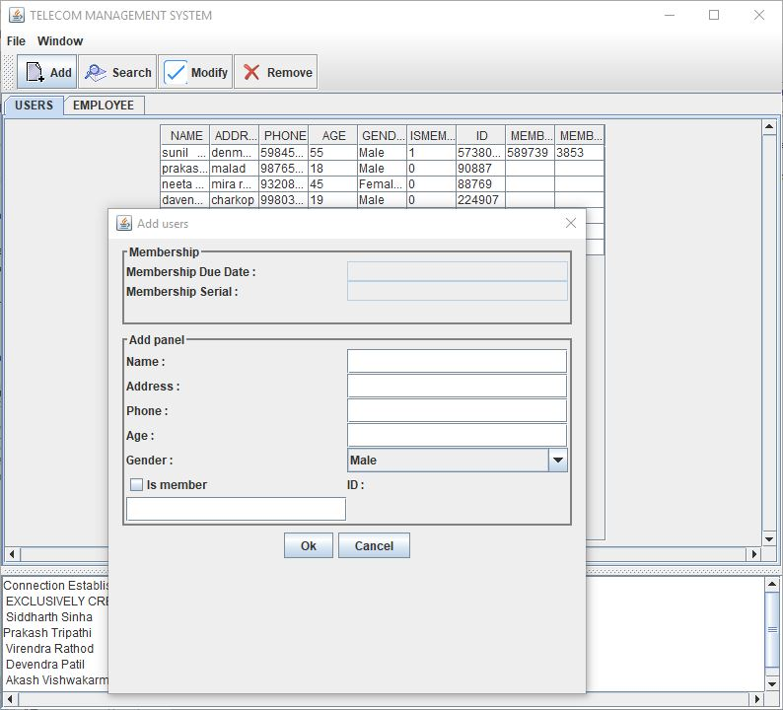

1. Click on ‘Employee’ tab to open employee database records.

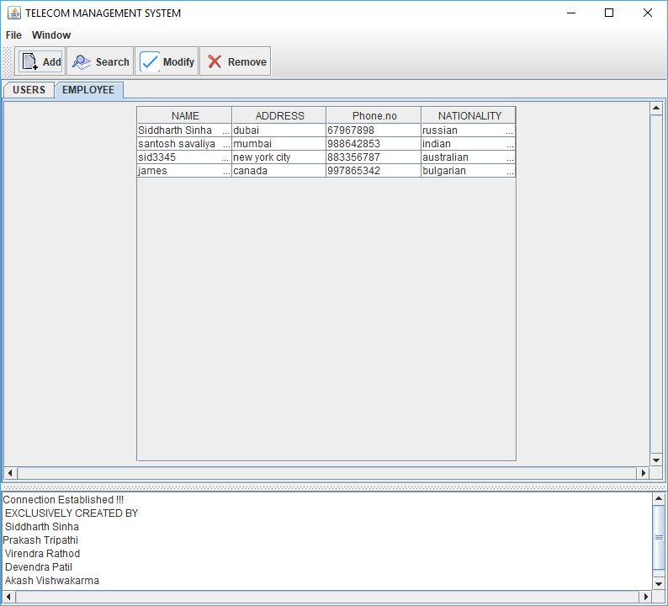

1. Click on Add while on ‘Employee’ tab to add new employee record (name, address, phone, nationality).

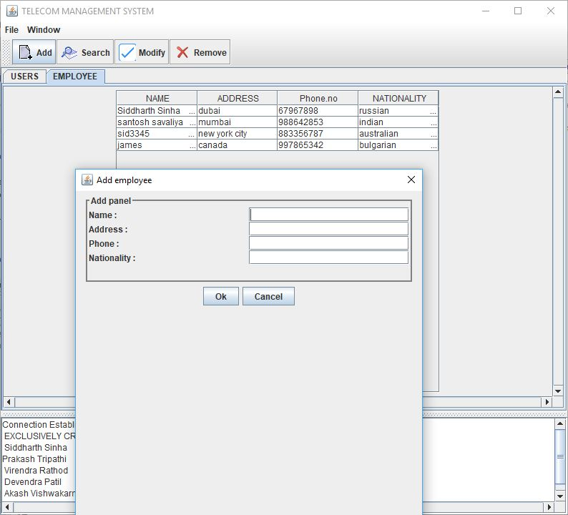

1. Click on ‘Search’ in any of ‘USER’ or ‘EMPLOYEE’ tab to search attributes name, address, phone, age, gender & membership serial if ismember is ticked.

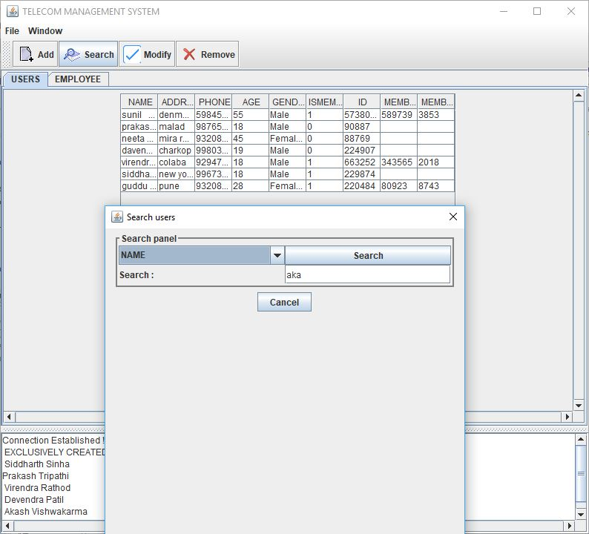

1. Click on ‘Modify’ panel in ‘USER’ or ‘EMPLOYEE’ tab to modify attributes(name, address, phone, age, gender)& select from list of records to modify.

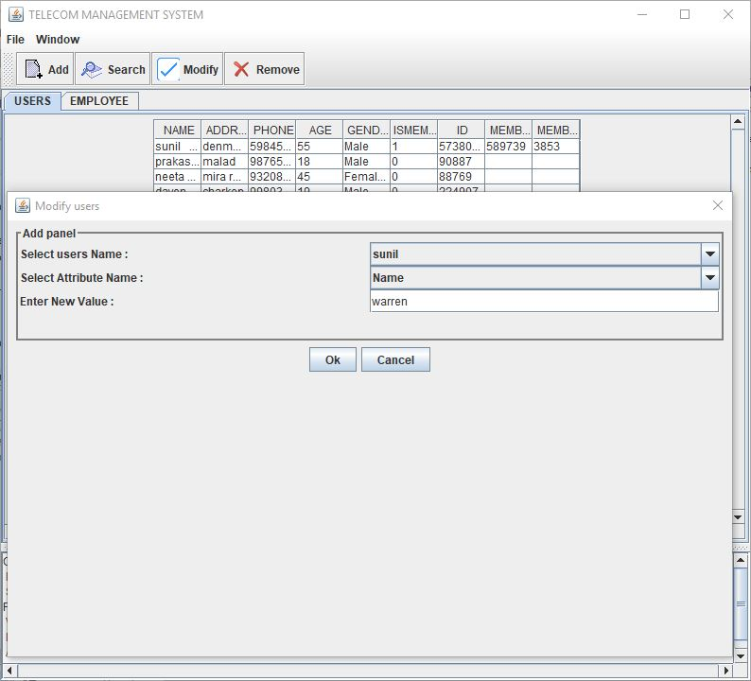

1. Click on ‘Remove’ panel in ‘USER’ or ‘EMPLOYEE’ tab to select record to be deleted.

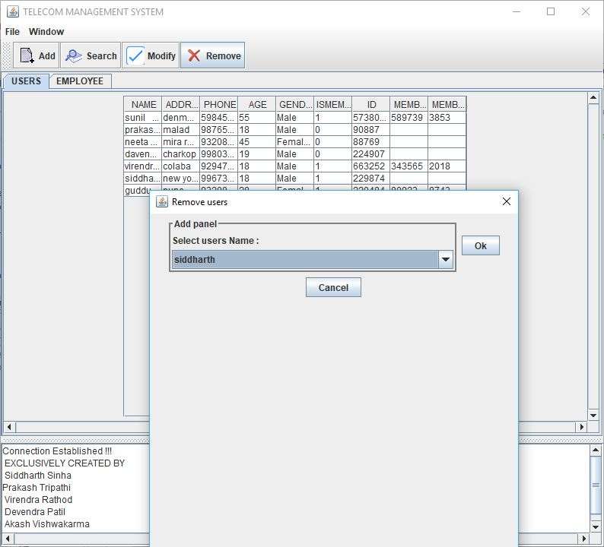

Conclusion

Hence, we have created an application using Java and Netbeans IDE and connected it to Oracle 10g database. The application stores records of users & employees & performs the functions such as ‘Add’, ‘Search’, ‘Modify’ & ‘Delete’. It was a great learning process while creating this project.